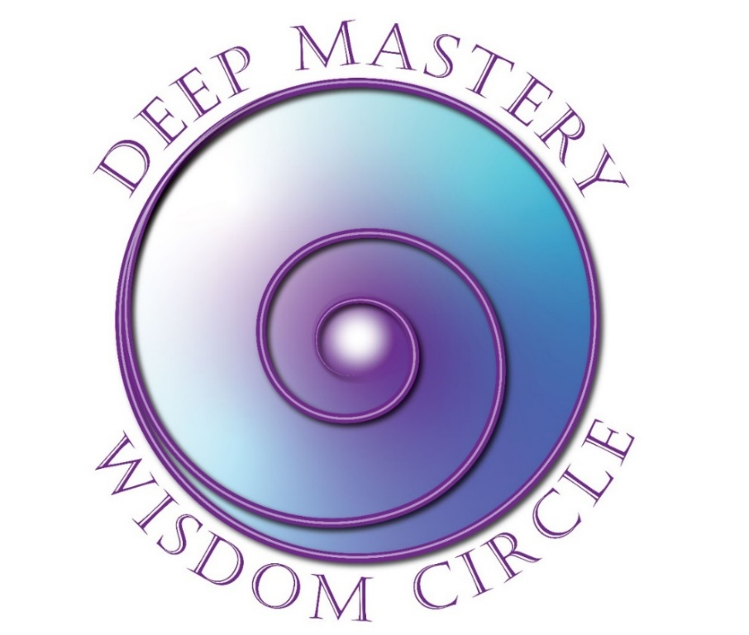

Registration
August 6 – December 3, 2025

Wednesdays Bi-Weekly: 8:00-9:30 PT/11:00-12:30 ET
Dates: August 6, 20; Sept 3, 17; Oct 1, 15, 29; Nov 5, 19; Dec 3

Yes! I want to register for Deep Mastery Wisdom Circle!

Please complete this 2-page form and mail or email it to Fran at the address on the next page.

Participant Information
Name
Address
City |  | State/Province |  | Zip
Email |  |  | Phone | ( )
Website

Payment Information
Program Fee: | $1,800 USD paid in full in advance
Early Bird Discount: | $1,600 paid in full before July 1, 2025
Cancellation | Cancel two weeks prior to the class start to receive full refund less $250 administrative fee.
Payment Methods:
Check: | Make checks payable to FJFisher Coaching and Consulting  (send to the address below)
PayPal: | Make your payment (in full or deposit) to Fran’s PayPal account: Fran@FranFisherCoach.com

Outcomes Desired
What attracted you to this program?
__________________________________________________________________________________________________________________________________________________________________________________________

What are you intending to experience/accomplish out of participating in this course?
__________________________________________________________________________________________________________________________________________________________________________________________

What other personal growth/experiential courses have you attended?
__________________________________________________________________________________________________________________________________________________________________________________________

Thank you for taking the time to complete this form.
This information will help me serve you better.

Fran Fisher, MCC
FJFisher Coaching and Consulting
2004 Rivers Edge Road, Windsor, CO 80550
(425) 753-6074
Fran@FranFisherCoach.com

