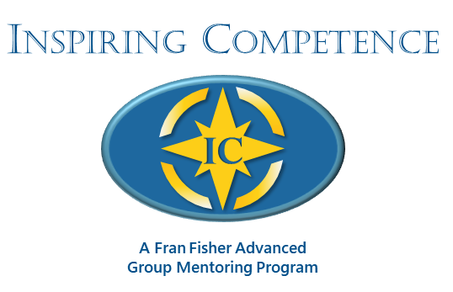

***Enhancing Your Presence and Power   
to Call Forth Your Client’s Greatness***

**Registration Form**

**Next Available Program: January 28 to June 3, 2025**

**Tuesdays: 11:00 to 12:30 PM (ET)**

***Jan 28, Feb 11, Feb 25, Mar 11, Mar 25, Apr 8, Apr 22, May 6, May 20, Jun 3***

*Orientation and Connection Pre-Course Call: January 14, 2025*

***Yes! I want to register for the Inspiring Competence Webinar Program  
starting January 28, 2025***

***Please complete this 2-page form, scan, and send it to my email address listed on the following page.***

**General Information**

|  |  |  |  |
| --- | --- | --- | --- |
| Name |  | | |
| Address |  | | |
| City |  | State | Zip |
| Phone | ( ) | Email | |
| Website |  | | |

**Payment Information**

|  |  |
| --- | --- |
| Program Fee: | $2,650 USD paid in full in advance  *Early Bird Discount: $2,550 paid in full before December 15, 2024* |
| PayPal: | Please make your payment(s) (in full or $500 deposit) to my PayPal account: fran@franfishercoach.com |

**Coach Training Courses or Programs I Have Attended:**

**Current Coaching Experience:**

# of Hours Coaching Experience to Date:

# of Coaching Clients Now:

ICF Credential Being Sought: PCC_________ MCC __________

**Outcomes Desired:**

What attracted you to this course? ____________________________________________________

What are you intending to experience out of taking this course?

**Your Learning and Feedback Preferences:**

What style or approach works best for you regarding feedback and suggestions?

When you feel challenged, what is one approach you take to stay on track toward your intended outcome?

What gets in your way regarding hearing feedback and suggestions?

What might you need more of or less of from your mentor coach?

*Thank you for taking time to complete this form. This information helps me serve you better. If you want more details about my Inspiring Competencies group program, feel free to email me.*

Fran Fisher, MCC

FJFisher Coaching and Consulting

Mobile: +1+425-753-6074 Email: fran@franfishercoach.com