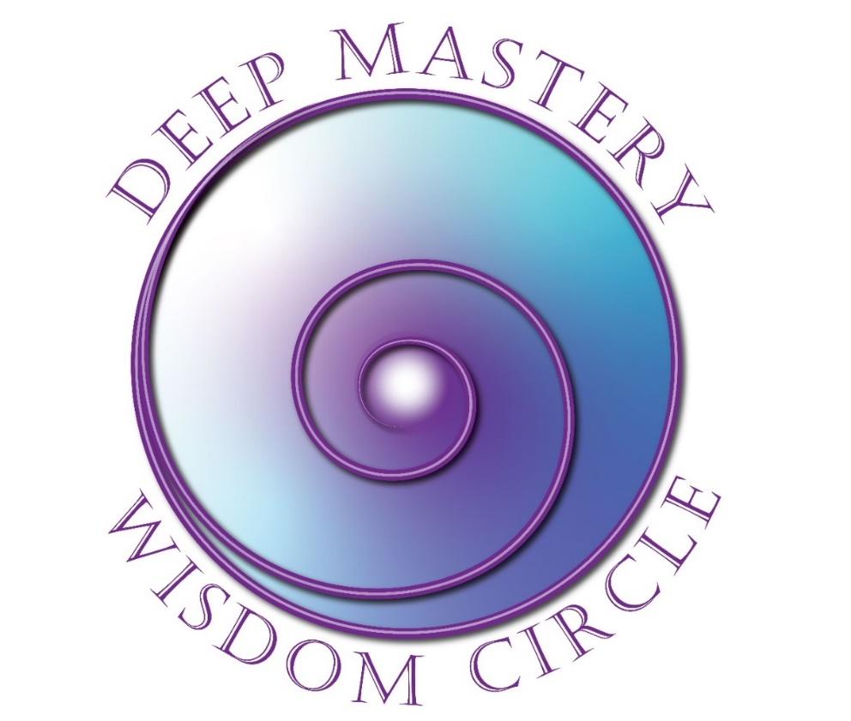

Registration
March 5 – July 9, 2025

Wednesdays: 11:00 AM - 12:30 PM ET
Dates: March 5, 19; April 2, 16, 30; May 14, 28; June 11, 25; July 9

Yes! I want to register for Deep Mastery Wisdom Circle!

Please complete this 2-page form and mail or scan and email.
Participant Information
Name
Address
City |  | State/Province |  | Zip
Email |  |  | Phone | ( )
Website
Payment Information

Program Fee: $1,350 USD paid in full in advance
Early Bird Discount: $1,150 paid in full before February 1, 2025
Cancel two weeks prior to the class starting to receive full refund less $250 administrative fee.

Check: | Make checks payable to FJFisher Coaching and Consulting  address below  Or:
PayPal: | Make your payment (in full or deposit) to MY PayPal account at: Fran@FranFisherCoach.com

Outcomes Desired

What attracted you to this Program?
__________________________________________________________________________________________________________________________________________________________________________________________

What are you intending to experience/accomplish out of participating in this course?
__________________________________________________________________________________________________________________________________________________________________________________________

What other personal growth/experiential courses have you attended?
__________________________________________________________________________________________________________________________________________________________________________________________

Thank you for taking time to complete this form. This information will help me serve you better.

Fran Fisher, MCC
FJFisher Coaching and Consulting | Office Phone: +1 (970) 833-5447
2004 Rivers Edge Road | Text: (425) 753-6074
Windsor, CO 80550 | Email: Fran@FranFisherCoach.com

